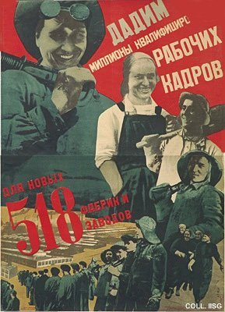 |  | Gustav Klutsis, 1931  Let's send millions of qualified worker cadres to the 518 new factories and production units  Publisher: Ogiz-Izogiz, Moscow/Leningrad  (Lithography, 143.5x103 cm., inv.nr. BG M1/135)  The often forced employment in the new factories in Siberia and other remote areas is pictured as a matter of voluntary enthousiasm. The parade of workers swings through the picture plane, bringing about a splendid spatial effect. In the lower right corner small text is printed, encouraging people to send comments on this poster to the publisher. Given the political climate of these years, this has more to do with enforcing ever stricter political discipline than with stimulating an open debate.

