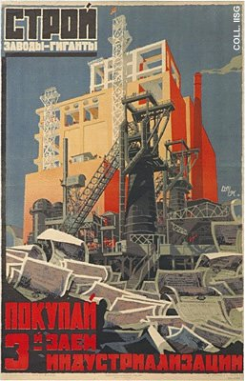 |  | S. Mirzoyan, A. Ivanov, 1929  Help build the gigantic factories  Publisher: AChR, Moscow  (Lithography, 111.5x80 cm., inv.nr. BG G1/231)  The first Five Year Plan aims to build up heavy industry from virtually nothing. This poster advertizes a state loan for the building of large factories.

