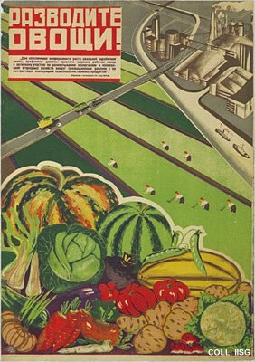 |  | A. Kuznetsova, A. Magitson, ca. 1930  Cultivate vegetables!  Publisher: AChR, Moscow  (Lithography, 101.5x71 cm., inv.nr. BG L3/207)  Workers are encouraged to cultivate vegetables near factories. On the poster, a realistic still life is combined with a modern constructivist background. It is issued by the publishing company of AChR, the Association of Revolutionary Artists. This organization is the main promotor of Socialist Realism and develops a stranglehold on the visual arts.

