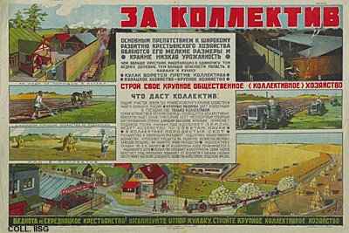 |  | S. Mirzoyan, A. Ivanov, 1929  Towards the collective  Publisher: AChR, Moscow  (Lithography, 71x107cm., inv.nr. BG E5/542)  The collectivization of agriculture means the forced merging of small private farms into large state enterprises. Here, the private farmer is pictured as a rich saboteur, jealous of the abundant harvest of the colelctive farm. In reality, rich farmers had already been disposed of. The remaining private farms were small, owned by poor peasants. The forced collectivization caused severe food shortages for years and years.

