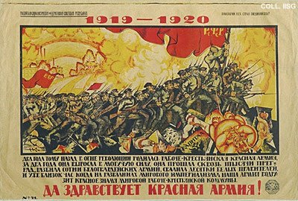 |  | Nikolay Kochergin, 1920  Long live the Red Army  Publisher: Revvoensovet, Moscow  (Lithography, 71x105 cm., inv.nr. BG E11/910)  Trampled beneath the feet of the Red Army are the defeated White generals and the idol of Mammon, symbol of capitalism.

