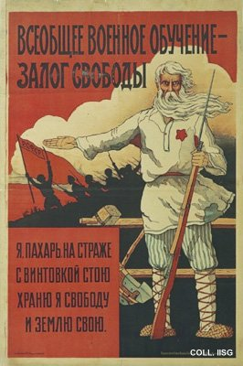 |  | Designer unknown, 1919  A general military training is a safeguard for freedom  Publisher: Vsebovuch, Moscow  (Lithography, 110.5x74.5 cm., inv.nr. BG L3/210)  In the years following 1917, the Soviet Union is torn by a bloody civil war between the 'Reds' (the communists) and the 'Whites'. This poster calls for the farmers to fight on the side of the Reds.

