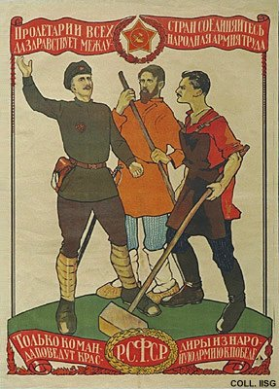 |  | Dimitry Moor, 1919  Proletarians of all countries, unite!  (Lithography, 97x69.5 cm., inv.nr. BG L3/208)  Soldier, farmer and worker: the new rulers. The text at the top, 'Proletarians of all countries, unite', is taken from the Communist Manifesto by Karl Marx and Friedrich Engels (1848). The emblem of a hammer and a plough, in the red star at the centre above, is soon replaced by the familiar hammer and sickle.

