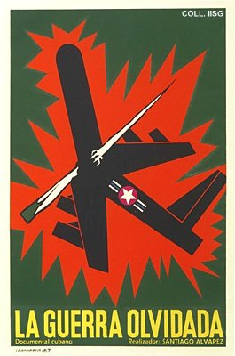 |  | Alfredo Rostgaard, 1967  The forgotten war  Publisher: ICAIC  (Silkscreen, 76.5x51 cm., inv.nr. BG E3/915, coll. Martinez)  Documentary by the innovating director Alvarez on the fight in Laos against the American army. Rostgaard shows a confrontation between a traditional wepaon and a sophisticated American bomber

