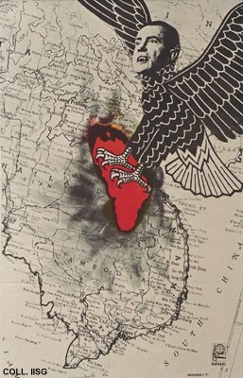 |  | René Mederos, 1971  Nixon  Publisher: OSPAAAL  (Offset, 54x34.5 cm., inv.nr. BG D12/952)  In 1970 and 1971, the Vietnam War spreads to the neighbouring countries. Richard Nixon, President of the United States, orders heavy bombardments to be carried out on Laos and Cambodia. Here he is depicted as a bird of prey

