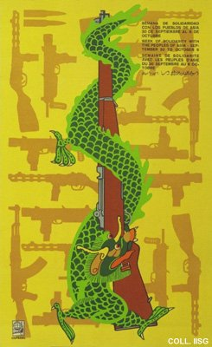 |  | Jesus Forjans, 1967  Week of solidarity with the peoples of Asia  Publisher: OSPAAAL  (Offset, 53.5x33 cm., inv.nr. BG D12/866, coll. Martinez)  See commentary to nr. 20.

