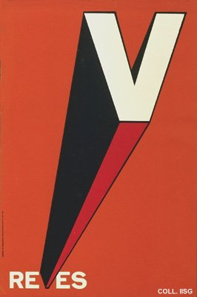 |  | Eufemia Alvarez, 1970  Setback  Publisher: Comisión de Orientación Revolucionaria  (Silkscreen, 91x61 cm., inv.nr. BG E3/815)  The sugar harvest of 1970 is big, but the desired ten million tons are not obtained. A comforting slogan is introduced: try to turn this setback ('reves') into a victory ('V' for 'victoria')

