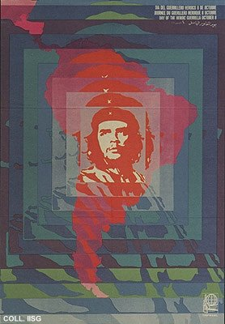 |  | Elena Serrano, 1968  Day of the Heroic Guerrilla  Publisher: OSPAAAL  (Offset, 49.5x34.5 cm., inv.nr. BG D12/845)  In Bolivia, Che Guevara tries to get a revolutionary process going to 'liberate Latin America from American imperialism'. In practice, his group of rebel fighters remains very small, receives little support from the population and has no military success at all. As a symbol and source of inspiration however, Che's importance can hardly be overestimated. Posters like this one are spread worldwide and help making Che a universal icon of revolutionary romanticism

