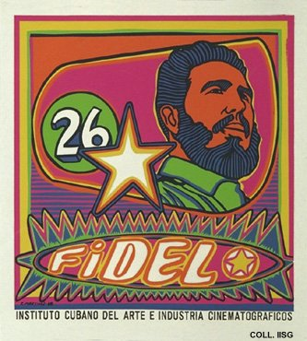 |  | Raul Martínez, 1968  Fidel  Publisher: ICAIC  (Silkscreen, 56x51 cm., inv.nr. BG E3/895, coll. Martinez)  Fidel Castro was and is the undisputed leader of the Cuban revolution. He does have his official titles and surnames, but is more often referred to as 'Fidel'. Martínez portrays him informal and cheerful. From his first abstract expressionist posters, Martínez has developed to a figurative style with simple forms and glaring colours that owes much to Latin American folk art and to Pop Art.

