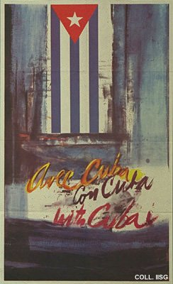 |  | Raul Martínez, 1966  With Cuba  (Offset, 85x52x cm., inv.nr. BG E3/849)  In 1966, a commission of the Central Committee of the Communist Party invites artists to provide designs for political posters that abandon the socialist realist stereotypes. A fresh and original approach is desired; the posters are to show the unconventional and independent direction Cuban communism is taking. Rostgaard, Fremez and Martínez provide designs that start the heyday of Cuban poster art. This is the design by Raul Martínez, up till then working as an abstract expressionist painter

