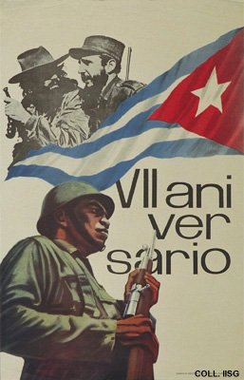 |  | Designer unknown, 1966  Seventh anniversary  Publisher: Comisión de Orientación Revolucionaria  (Offset, 70x45 cm., inv.nr. BG E3/833)  In the upper left corner a picture of Castro and his comrade in arms Camilo Cienfuegos during their triumphant entry into Havana, January 1959. The long hairs and beards from their time as guerrillas remain distinguishing features of the Cuban revolutionary leaders

