Gang of Four

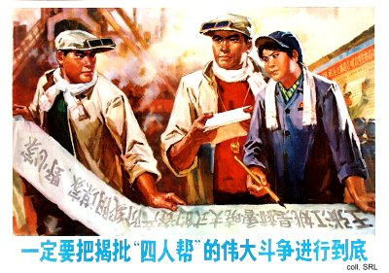
The 'Gang of Four' was formed by Mao Zedong's wife Jiang Qing (1913-1991), the Shanghai Propaganda Department official Zhang Chunqiao (1917-1991), the literary critic Yao Wenyuan (1931) and the Shanghai security guard Wang Hongwen (1935-1992). They rose to power during the Cultural Revolution (1966-1976) and dominated Chinese politics during the early 1970s.
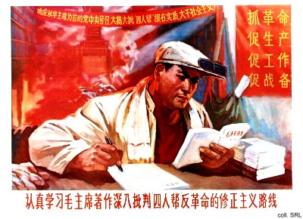
After Mao's death in September 1976, they were arrested; in 1980 they were tried in court. Jiang Qing and Zhang Chunqiao, seen as the leaders, received (suspended) death sentences, while Yao Wenyuan and Wang Hongwen, considered the henchmen, were given lengthy prison sentences. Of the four, only Yao, who was released in 1997, is still alive.
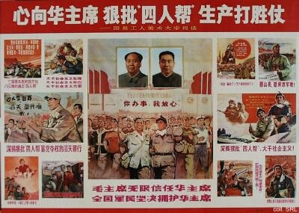
After the Gang was arrested, a huge propaganda campaign was launched to discredit them. Nonetheless, relatively few striking posters were produced to accompany the campaign. The poster below is the harshest I've ever seen.
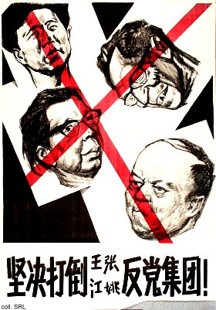
Aside from an avalanche of cartoons poking fun at the four (cartoons being the favored medium for attacking political opponents), most posters consisted of scenes of jubilation or mass criticism. The poster below, produced in the famous New Year Print studio of Yangliuqing (Tianjin) in 1978, combines both cartoons and the traditional nianhua style.
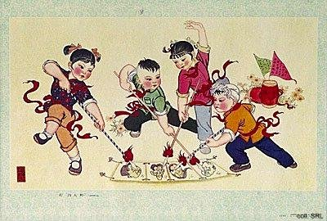
Sources:
A Great Trial in Chinese History—The Trial of the Lin Biao and Jiang Qing Counter-Revolutionary Cliques, Nov. 1980-Jan. 1981 (Peking: New World Press, 1981)
Wolfgang Bartke, Who was Who in the People's Republic of China (München: K.G. Sauer, 1997)
Wolfgang Bartke, Biographical Dictionary and Analysis of China's Party Leadership 1922-1988 (München: K.G. Sauer, 1990)
David Bonavia, Verdict in Peking—The Trial of the Gang of Four (London: Burnett Books, 1984)
Yan Jiaqi & Gao Gao (translated & edited by D.W.Y. Kwok), Turbulent Decade—A History of the Cultural Revolution (Honolulu: University of Hawai'i Press, 1996)
Yang Kelin (ed.),Wenhua dageming bowuguan [Museum of the Cultural Revolution] (Hong Kong: Dongfang chubanshe youxian gongsi, Tiandi tushu youxian gongsi, 1995) [in Chinese]

