The Elderly

My mother-in-law once pointed out that in most Chinese propaganda posters, elderly people are not represented, with the exception of the leaders. Given the traditional veneration of old age in Chinese culture, this indeed is remarkable.
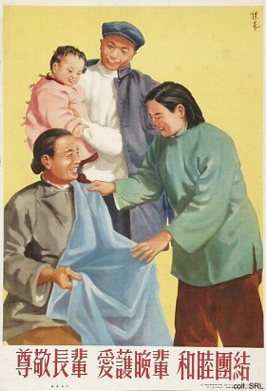
However, as early as the 1950s, old people have appeared in posters, although not frequently and often only in the background. In many cases, the depiction of the elderly is used to teach lessons in social morality.
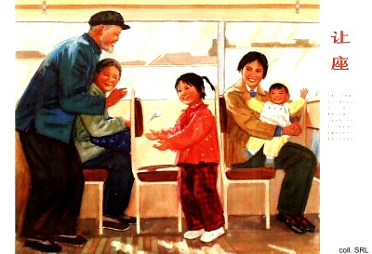
In the 1980s, the elderly practically disappear, except in a few posters where they are no longer pictured while taking an active part in various activities, but as people in need of care. Lacking a comprehensive system for old-age security, care for the elderly will become a major problem for China in the decades to come.
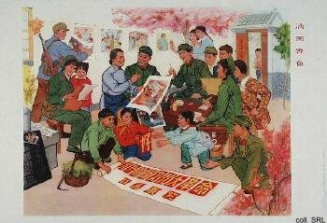 | 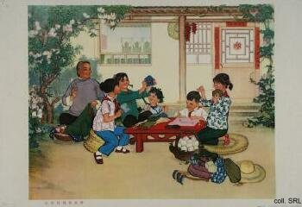
As the images above already indicate, whenever elderly people are represented, they are usually women, engaged in three types of activities: looking after the (grand)children; spending time on typically feminine pursuits such as needlework; and supporting the Army. The last activity is intended to show the close relations between the people and the Army. In other cases, elderly people are shown reminiscing about the bad old days, or eating bitterness.
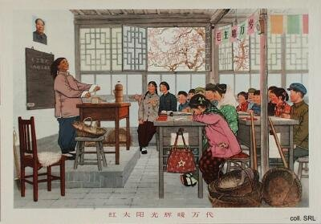
In a few rare instances, older men have been pictured while recounting their war-time experiences.
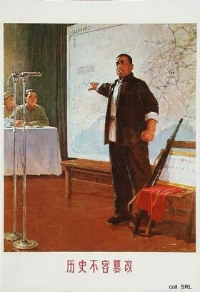
More often, elderly people are used as contrast with the past, as a way to show how much China has changed, or improved, since the founding of the People's Republic. They invariably stand in awe of the new China.
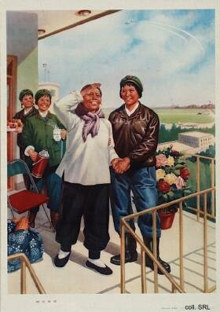 | 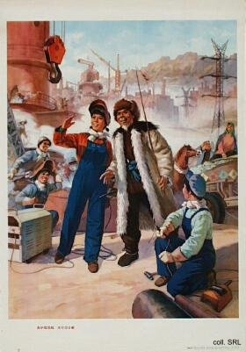
In the 1980s, the elderly only made rare appearances, usually showing them as people who needed help with shopping, or while crossing the street, or a more general type of care.
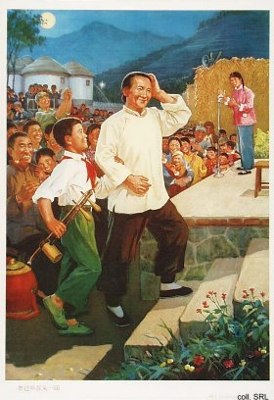 | 